

Designing an AWS Control Tower land
Best Practices Guidance
For Brunei Shell Petroleum (BSP) by Trianz
AWS Prescriptive Guidance: Designing an AWS Control Tower landing zone
TRIANZ CONFIDENTIAL

trianz.com

Table of Contents
1. Designing an AWS Control Tower landing zone 4
2. Targeted business outcomes 4
3. Process 4
4. AWS services 5
5. Conﬁguring account structure and Ous 7
5.1 Security OU 9

5.1.1 Log Archive account 9

5.1.2 AWS Services used in Log Archive Account 10
5.1.2.1 Amazon Security Lake 10
5.1.2.2 Amazon S3 for Log Storage and Archiving 10
5.1.2.3 AWS Security Hub 10
5.1.2.4 AWS GuardDuty 10

5.1.3 Audit account 10
5.1.3.1 AWS Services used in Audit Account 10
5.1.3.2 AWS Audit Manager 10
5.1.3.3 AWS CloudTrail 10
5.1.3.4 AWS Config 11
5.1.3.5 AWS Inspector 11
5.1.3.6 AWS Audit Manager 11
5.2 Sandbox OU 11
5.3 Infrastructure OU: 12

5.3.1 Backup account: 12
5.3.1.1 IAM Identity Center 13
5.3.1.2 IAM Access Analyzer 14
5.3.1.3 AWS Directory Services 14
5.3.1.4 SAML 2.0 custom managed applications 14

5.3.2 Network account: 14
5.3.2.1 AWS Services used in Network Account: 14
5.3.2.2 AWS Network Manager 14
5.3.2.3 IPAM 14
5.3.2.4 VPC Reachability Analyzer 15
5.3.2.5 AWS Transit Gateway 15
5.3.2.6 NAT Gateway 15
5.3.2.7 Local Gateway 15
5.3.2.8 Amazon Route 53 Endpoint Resolver 15
5.3.2.9 AWS Site-to-Site VPN connections 15
5.3.2.10 Centralized network inspection point 15
5.3.2.11 VPC 15
5.3.2.12 Subnet 16
5.3.2.13 Security Groups 16
5.3.2.14 NACL (Network Access Control List) 16
5.3.2.15 VPC flow logs 16
5.3.2.16 Operations Tooling account: 16

5.3.3 AWS Services used in Operations Tooling Account: 17
5.3.3.1 AWS Account Management 17
5.3.3.2 AWS License Manager 17
5.3.3.3 AWS Health 17
5.3.3.4 Monitoring account 17

5.3.4 AWS Services used in Operations Tooling Account: 17
5.3.4.1 AWS Health 17
5.3.4.2 AWS CloudWatch 18
5.3.4.3 CloudWatch dashboards 18
5.3.4.4 Shared Services accounts: 18
5.3.4.5 AWS Service Catalog 18
5.4 Workload OU 18

5.4.1 AWS Control Tower Account Factory 19

5.4.2 AWS Control Tower add-ons 19
6. FAQ 20

Designing an AWS Control Tower landing zone
We begin BSP’s cloud adoption journey by conceptualizing and designing a landing zone, which is a well-architected, multi-account AWS environment that is scalable and secure. A landing zone creates an agile and scalable cloud environment. It also helps to quickly launch and deploy workloads and applications into infrastructure, which helps accelerate BSP’s digital transformation and cloud journey.
This guide is for BSP that have decided to set up an AWS Control Tower landing zone and want to create a design document that covers the key functionality of the landing zone. The guide covers best practices and patterns for setting up the account structure and conﬁguring networking, logging, authentication, and other aspects of the landing zone. It also provides examples of how to present this information in BSP design documents. The key outcome from this exercise is a design artifact that documents the decisions that were made and the architectures that were agreed upon as the basis of implementing the landing zone.

Targeted business outcomes
You should expect the following business outcomes from using this design guide:
- Lead design conversations for an AWS Control Tower landing zone conﬁdently.
- Address all foundational pillars of an AWS Control Tower landing zone eﬀectively.
- Create a strong foundation for migrating workloads to the AWS Cloud.

Process
BSP IT infrastructure teams and Trianz architects usually create a design document that addresses the important parts of a landing zone. Stakeholders must approve the design document before the landing zone is implemented. This guide accelerates the design process for IT infrastructure teams, architects, and cloud migration teams by providing a landing zone design template that's aligned with the AWS Well-Architected Framework. It helps to accelerate BSP’s cloud adoption by outlining the foundational pillars of the landing zone design.
The key landing zone topics covered in this design guide are:
- Setting up a landing zone – Provides an overview of the basic landing zone setup, including where it should be deployed, which parameters to use, and which resources are deployed.
- Conﬁguring account structure and OUs – Shares a sample account structure that includes diﬀerent accounts and organizational units (OUs) for a landing zone.
- Using controls to govern resources and monitor compliance – Identiﬁes and explains the preventive, detective, and proactive controls that must be enabled in AWS Control Tower for the landing zone's governance.
- Networking integration – Helps to design connectivity between the virtual private clouds (VPCs) in landing zone and on-premises applications by using native AWS services such as AWS Transit Gateway, AWS Direct Connect, and AWS Site-to-Site VPN.
- Authentication and authorization – Explains how AWS IAM Identity Center integrates with AWS Control Tower and how to integrate BSP’s identity provider (If required).
- Centralizing logging and monitoring – Reviews the monitoring, logging, log archival, and alerting strategy for the landing zone.
- Managing the conﬁguration of AWS resources – Explains how you can manage resource conﬁgurations, track changes, and view compliance data by using AWS Conﬁg.

AWS services
This design guide covers the following AWS services to set up the landing zone:
- AWS Control Tower automates the landing zone setup by using best practices for identity, federated access, controls, and account structure.
- AWS CloudTrail integrates with AWS Control Tower, captures actions as events, and provides a record of actions taken by a user, role, or AWS service.
- AWS Conﬁg helps to assess, audit, and evaluate the conﬁgurations of AWS resources. AWS Control Tower automatically enables AWS Conﬁg in its AWS Regions and uses it to implement detective controls. The conﬁguration history and snapshots are delivered to an Amazon Simple Storage Service (Amazon S3) bucket in the Log Archive account.
- AWS Direct Connect/Site to Site VPN establishes a dedicated network connection from on-premises environments to the AWS Cloud, and AWS Outpost.
- AWS Identity and Access Management (IAM) helps securely control access to AWS resources. IAM or IAM Identity Center authenticates that user is an approved user before user perform operations, such as provisioning accounts in creating new OUs in the AWS Control Tower console, in landing zone.
- AWS Organizations is an account management service that consolidates multiple AWS accounts into an organization that BSP centrally manages. In AWS Control Tower, AWS Organizations helps BSP/Trianz to centrally manage billing, control access, compliance, and security, in addition to sharing resources across member accounts.
- Amazon CloudWatch monitors the resources and applications that run on AWS. CloudWatch cross-account observability let BSP/Trianz to monitor and troubleshoot applications that span multiple accounts within a Region.
- Amazon GuardDuty continuously monitors malicious activity and unauthorized behavior to protect AWS accounts, workloads, and the data stored in Amazon S3.
- AWS IAM Identity Center is a cloud-based single sign-on (SSO) service that helps BSP to centrally manage SSO access for all BSP AWS accounts and cloud applications. AWS Control Tower integrates with IAM Identity Center to manage users, roles, and multi-account access.
- Amazon Simple Storage Service (Amazon S3) is a cloud-based object storage service that helps to store, protect, and retrieve any amount of data. S3 buckets store the AWS Control Tower logs and AWS access logs.
- AWS Systems Manager provides a uniﬁed user interface (UI) to centrally track and resolve operational issues across applications and resources.
- Amazon Simple Notiﬁcation Service (Amazon SNS) helps to coordinate and manage the exchange of messages between publishers and clients, including web servers and email addresses. AWS Control Tower sends security notiﬁcations, such as non-compliance with detective controls, to SNS topics that clients can subscribe to.

Conﬁguring account structure and Ous
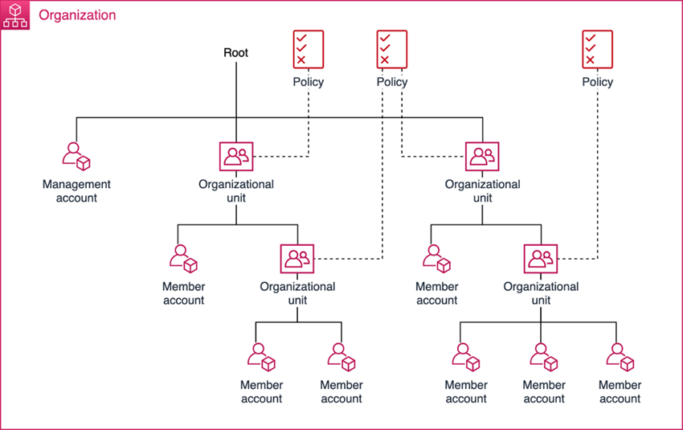
AWS accounts are resource containers that assist users in managing AWS resources. As needs and demands grow, environments scale through the addition of new accounts. The use of multiple accounts is a best practice because it enables rapid innovation across distributed teams and individuals, reduces the scope of impact through isolation, and can be adjusted to meet new business processes based on operational, regulatory, and budgetary requirements. Lastly, costs are incurred at the account level, so activity and costs can be identiﬁed with each account.
The following diagram provides an example of an AWS Control Tower‒based account structure that includes various accounts and OUs and follows AWS best practices. BSP can customize this architecture based on the account structure that's suitable for BSP.
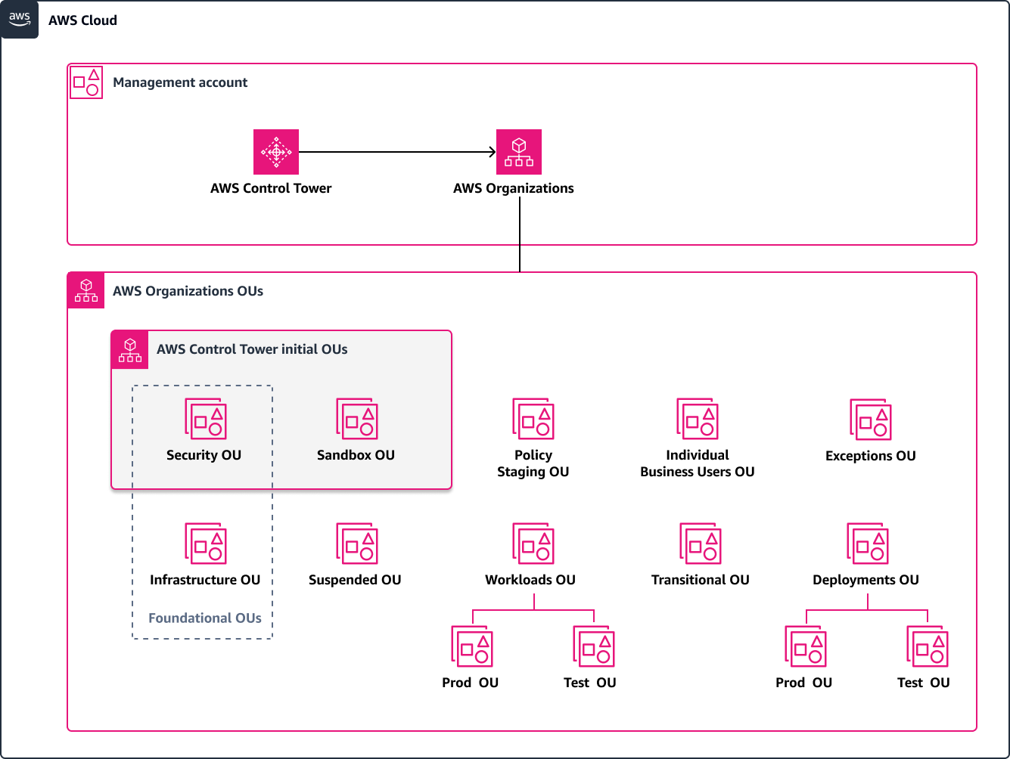
The account in which AWS Control Tower is deployed is automatically conﬁgured as the AWS Control Tower management account. The management account consolidates the billing of all accounts in the landing zone. This account is used to provision new AWS accounts with AWS Control Tower Account Factory, manage OUs and controls, and manage user access and permissions by using IAM Identity Center.
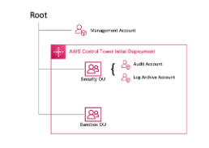
The diagram includes the following key OUs.

Security OU
Automatically set up by AWS Control Tower to host the Log Archive and Audit accounts.
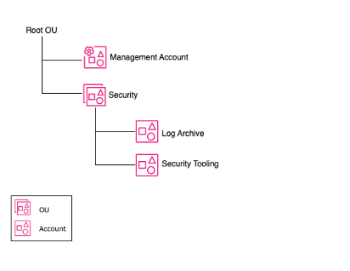

Log Archive account
AWS Control Tower centralizes all AWS CloudTrail and AWS Conﬁg logs into a centralized S3 bucket. You can also centralize other logs from across your organization, such as Amazon CloudWatch logs, Amazon S3 access logs, and VPC Flow Logs, in this account.

AWS Services used in Log Archive Account

Amazon Security Lake
Amazon Security Lake centralizes security data from cloud, on-premises, and custom sources into a data lake that's stored in your account.

Amazon S3 for Log Storage and Archiving
S3 is often used as the destination for log files, including CloudTrail logs and CloudWatch logs

AWS Security Hub
aggregates, organizes, and prioritizes security alerts from various AWS services

AWS GuardDuty
This is a continuous security monitoring service that analyzes data for signs of malicious activity, such as unusual API calls or unauthorized access.

Audit account
Provides read and write access to all accounts in your landing zone. From the Audit account, you can programmatically review accounts by using a role that is granted only to AWS Lambda functions. Your security and compliance teams can use the Audit account to audit and review the accounts in your organization.

AWS Services used in Audit Account

AWS Audit Manager
Continuously audit your AWS using across multiple accounts in your organization to simplify how you assess risk and compliance. Recommended to be in same AWS account AWS Security Hub delegated admin exists.

AWS CloudTrail
The management of CloudTrail Org Trails can be delegated to one account. It is recommended that the Security team manage the implementation.

AWS Config
Organization-wide aggregated view of your AWS resources, your AWS Config rules, and the AWS resources’ compliance state. Creating an organization aggregator can be done across multiple AWS regions into the region the aggregator is being deployed to. Multiple accounts can be delegated to the AWS Config aggregator.

AWS Inspector
Used to scan Lambda function code for known software vulnerabilities and unintended network exposure

AWS Audit Manager
Helps you to continually audit your AWS usage to simplify how you manage audits and compliance with regulations and industry standards

Best practices & Recommendations for Security OU

Compliance in AWS Outposts
AWS Outposts extends AWS services on-premises, creating unique security challenges. To maintain compliance, manage risks, monitor activity, and respond to incidents, organizations must implement strong security controls.
Recommendations:
Key Security Controls for Compliance:
- Data Residency & Sovereignty: Ensure data stored in AWS Outposts complies with regional data protection laws (e.g., GDPR, CISPE, etc.).
- Service Control Policies (SCPs): Restrict Outpost modifications and resource deployments to approved AWS regions.
- Encryption for Data at Rest and In Transit: Use AWS Key Management Service (KMS) for Outposts to encrypt stored and transmitted data.

Risk Management in AWS Outposts
Risk management for AWS Outposts focuses on identifying, assessing, and mitigating risks related to security, data breaches, and infrastructure failures.
Key Security Controls for Risk Management
- Least Privilege Access: Use IAM roles and permissions to ensure users only have the minimum access necessary.
- Security Groups & Network ACLs: Enforce strict network segmentation to isolate Outposts workloads from other on-premises resources.
- Physical Security Controls: AWS monitors tampering of Outpost hardware; customers should implement on-premises access restrictions.
- Data Backup and Disaster Recovery: Use AWS Backup or cross-region replication to protect against data loss.

Monitoring & Logging in AWS Outposts
Continuous monitoring is essential for detecting security threats, performance issues, and unauthorized access.
Key Security Controls for Monitoring
- Amazon CloudWatch: Monitor system performance, CPU usage, network traffic, and storage metrics on Outposts.
- AWS CloudTrail: Enable CloudTrail logs for all AWS API activities on AWS Outposts, including changes to EC2 instances and S3 storage.
- Amazon GuardDuty: Detect suspicious activity, including unauthorized API calls, unusual traffic patterns, and malware indicators.
- AWS Config: Track configuration changes in Outposts resources to detect misconfigurations or unauthorized modifications.
- VPC Flow Logs: Analyze network traffic between AWS Outposts and other on-prem or AWS Region resources.
- Security Information and Event Management (SIEM) Integration: Send logs to AWS Security Hub, Splunk, or ELK Stack for centralized monitoring.
- AWS Systems Manager: Manage and patch AWS Outposts instances remotely using Systems Manager Agent (SSM).
Best Practices for Securing AWS Outposts
- Enforce IAM Security – Use IAM roles, SCPs, and MFA for Outposts access.
- Encrypt Everything – Ensure end-to-end encryption for Outposts data using AWS KMS.
- Monitor All Traffic – Enable CloudTrail, GuardDuty, and VPC Flow Logs for Outposts security visibility.
- Limit Internet Exposure – Use private VPCs and security groups to restrict Outposts access.
- Regularly Test Incident Response Plans – Conduct tabletop exercises for Outposts security incidents.

Recommendations for Data Protection and Compliance in AWS Outposts

Encryption at Rest
Encryption by Default: All data stored on AWS Outposts is encrypted by default. You can use AWS Key Management Service (KMS) to manage encryption keys.
- Customer-Managed Keys (CMKs): You can create and manage your own KMS keys to control encryption at rest.
- Nitro Security Key (NSK): AWS Outposts uses the Nitro Security Key to protect encryption keys and ensure hardware security.
Hardware-Based Security: Outposts is built on AWS Nitro hardware, which includes dedicated security capabilities, such as the encryption of data at rest and key management.

Encryption in Transit
TLS/SSL Encryption: Ensure that all data in transit is encrypted using Transport Layer Security (TLS) or Secure Socket Layer (SSL) protocols.
- VPC Traffic: Use AWS Virtual Private Cloud (VPC) to establish secure communication channels between your resources on Outposts and other AWS services.
- AWS Direct Connect or VPN: For private, dedicated network connections, ensure that traffic between your on-premises systems and AWS is encrypted using VPN or AWS Direct Connect.

Access Control and Identity Management
IAM Roles and Policies: Use AWS Identity and Access Management (IAM) to enforce fine-grained control over who can access data and resources on Outposts.
- Assign least-privilege IAM roles to users and EC2 instances running on Outposts to ensure that only authorized users can access sensitive data.
- Enable multi-factor authentication (MFA) for users with administrative access to protect against unauthorized access.

Data Backup and Recovery
Automated Backups: Use AWS Backup to automate backup and restore processes for EC2 instances, databases, and other resources on Outposts.
Cross-Region Backup: For added redundancy, use cross-region backups to replicate backups of your Outposts data to other AWS regions.

Audit and Compliance Reports
AWS CloudTrail enables you to log, continuously monitor, and retain account activity related to actions taken on your AWS resources. CloudTrail is essential for auditing and tracking who did what and when on your AWS account.
Use AWS Config to continuously monitor the configuration of your Outposts resources and detect non-compliant configurations.
Integrate with AWS Security Hub for centralized management and aggregation of compliance-related findings across your AWS accounts and Outposts.

Use Continuous Security Monitoring
Enable Amazon GuardDuty for continuous threat detection. GuardDuty will automatically monitor for suspicious activity, such as unusual API calls or potential data exfiltration, within your Outposts environment.

Security & Compliance- Best Practices
Logging & Monitoring
Cloud Trail: The AWS CloudTrail service provides a comprehensive log of control plane and data plane operations (audit history) of all actions taken against most AWS services, including users logging into accounts.
VPC Flow Logs: VPC Flow Logs capture information about the IP traffic going to and from network interfaces in a VPC such as source and destination IPs, protocol, ports, and success/failure of the flow.
GuardDuty: Amazon GuardDuty is a cloud native threat detection and Intrusion Detection Service (IDS) that continuously monitors for malicious activity and unauthorized behavior to protect your AWS accounts and workloads.
Config: AWS Config provides a detailed view of the resources associated with each account in the AWS Organization, including how they are configured, how they are related to one another, and how the configurations have changed over time.
CloudWatch Logs: CloudWatch Logs is the AWS-managed log aggregation service. It is used to monitor, store, and access log files from EC2 instances, AWS CloudTrail, Route 53, and other sources.
Security Hub: Security Hub needs to be configured to aggregate findings from Amazon GuardDuty, Amazon Macie, AWS Config, Systems Manager, Firewall Manager, Amazon Detective, Amazon Inspector and IAM Access Analyzers. Events from security integrations are correlated and displayed on the Security Hub dashboard as ‘findings’ with a severity level (informational, low, medium, high, critical)
AWS Secrets Manager: It is a service designed to help you protect access to your applications, services, and IT resources without the upfront investment and ongoing maintenance costs associated with operating your own infrastructure for managing secrets
Best Practices
- Generating random passwords by using AWS Secrets Manager.
- It’s recommended to generate random passwords that are 20 characters long and that include numbers, exclude punctuation characters, and exclude spaces. You can modify this code example to meet the password security requirements for your organization.
- Using AWS Lambda to rotate secrets every 90 day Maximum.
AWS KMS (Key Management Service): AWS Key Management Service (AWS KMS) is a managed service that simplifies the creation and control of cryptographic keys used to encrypt your data
Best Practices
- Automatic Key Rotation: Enable automatic key rotation for AWS-managed keys (every 90 days) to reduce the risk of key compromise.
- Manual Key Rotation: For customer-managed keys, implement a key rotation policy. Create new keys and update your applications to use them periodically.
- Principle of Least Privilege: Apply the principle of least privilege by granting only the necessary permissions to users, roles, and services that need to use or manage keys.
Identity and Access Management (IAM): Centralized IAM roles and policies: Centralized IAM roles and policies refer to the practice of managing Identity and Access Management (IAM) roles and policies in a centralized manner within an organization's AWS environment.

Service Control Policies (SCPs) Overview:
- Policies to restrict actions at the OU and account levels with help of control Tower.
- Follow the principle of least privilege when defining SCPs. Only grant permissions necessary for users and roles to perform their specific tasks.
- Group accounts with similar requirements or functions under the same OU to apply SCPs consistently.
- Implement baseline SCPs that apply foundational security controls and restrictions across all accounts in your organization.

Sandbox OU
Set up by AWS Control Tower to host sandbox accounts that help you safely test and develop new services, processes, and templates. Team can explore and experiment with AWS services, and other tools and services. Resources that are created in sandbox environments are temporary in nature.

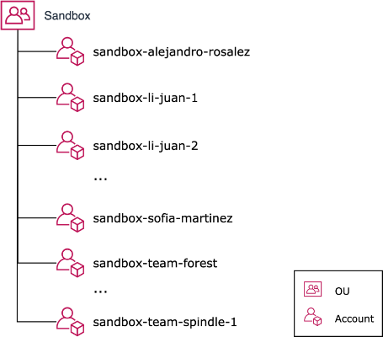

Infrastructure OU:
The Infrastructure OU is a foundational OU that is intended to contain infrastructure services. The accounts in this OU are also considered administrative and BSP’s infrastructure and operations teams should own and manage this OU, any child OUs, and associated accounts.
The Infrastructure OU is used to hold AWS accounts containing AWS infrastructure resources that are shared, utilized by, or used to manage accounts in the organization. This includes centralized operations or monitoring.
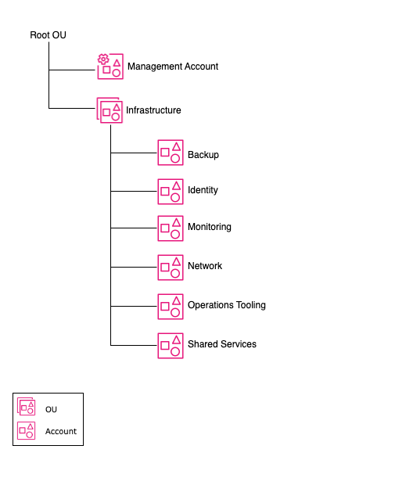

Backup account:
The Backup account serves as a dedicated and centralized hub for backup and disaster recovery management. It provides a unified location to orchestrate, monitor, and enforce backup policies across AWS accounts within the AWS Organization.
AWS Services used in Backup Account:
AWS Backup
Register the Backup account as the delegated administrator in the AWS Backup console.
AWS Organizations: AWS Backup policy administration
Delegate AWS Backup Policy administration to the Backup account by enabling delegation of AWS Organizations in the management account and configure a policy that allows the Backup account to create Backup Policies.
Identity account:
The Identity account serves as a centralized identity federation account isolated from all other management and workload activities within the AWS Organization. Federated identity management grants the ability to efficiently manage access to the accounts in the AWS Organization and authorize to integrated applications.
This helps to quickly create, update, and delete the permissions and policies that need to meet BSP’s business requirements.
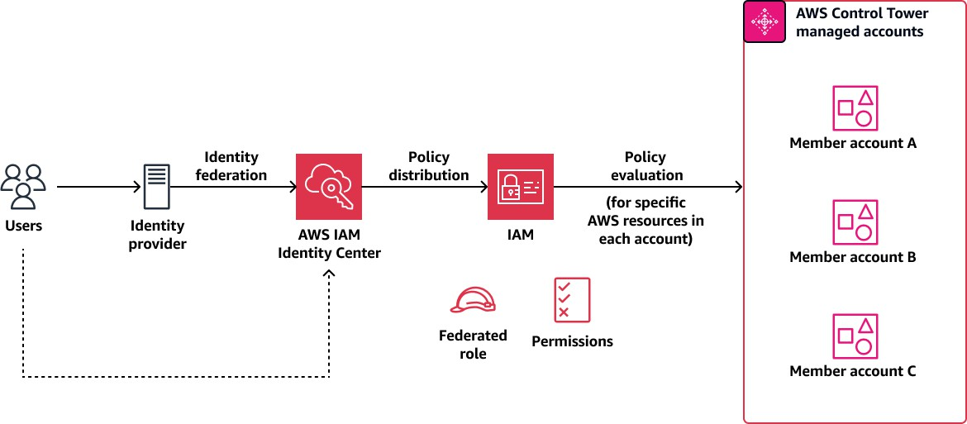
AWS Services used in Identity Account:

IAM Identity Center
Delegate administration of IAM Identity Center to this account which will allow BSP to administer IAM Identity Center outside of the management account.

IAM Access Analyzer
An IAM Access Analyzer can be configured to detect resources that are shared outside of the organization (organization zone of trust). By default, this is managed by the management account.

AWS Directory Services
If BSP intended to use an AWS-hosted directory or AWS AD Connector, we can create and manage them in your Identity account alongside of AWS IAM Identity Center.

SAML 2.0 custom managed applications
With the IAM Identity Center, BSP can create or connect workforce users and centrally manage their access across all their AWS accounts and applications.

Network account:
The Network account serves as the central hub for your network within your AWS Organization.
You can manage your networking resources and route traffic between accounts in your environment, your on-premises, and egress/ingress traffic to the internet. Within this account, your network administrators can manage and build security measures to protect network traffic across your cloud environment.

AWS Services used in Network Account:

AWS Network Manager
Centrally manage and monitor your global networks with transit gateways and their attached resources in multiple AWS accounts within your organization.

IPAM
Delegated to a single account for your entire AWS Organization. IPAM will inventory and track all active IPs across your AWS Organization.

VPC Reachability Analyzer
Trace paths across accounts in your organizations. You can assign multiple delegated admin accounts as needed.

AWS Transit Gateway
Create an AWS Transit Gateway resource in the networking account and share it across the accounts within your AWS Organization using AWS Resource Access Manager (RAM).

NAT Gateway
NAT gateway is a Network Address Translation (NAT) service. You can use a NAT gateway so that instances in a private subnet can connect to services outside your VPC but external services cannot initiate a connection with those instances.

Local Gateway
A local gateway enables connectivity between your Outpost subnets and your on-premises network.

Amazon Route 53 Endpoint Resolver
If you plan to use a centralized transitive network with Amazon Route 53 Public Data Plane in your AWS Organization, we recommend managing and sharing your Route 53 Endpoint Resolvers in your network account within your AWS organization.

AWS Site-to-Site VPN connections
Using a transitive network architecture centralized in your Network account, a site-to-site VPN can be established and routing enabled across your cloud environment.

Centralized network inspection point
Build inbound and outbound network traffic inspection points routing through the Network account.

VPC
AWS service that allows you to create a logically isolated network within AWS, where you can launch and manage AWS resources like EC2 instances and databases.

Subnet
A subnet is a range of IP addresses in your VPC. You launch AWS resources, such as Amazon EC2 instances, into your subnets.
Route tables route table is a set of rules, known as routes, that determines where network traffic is directed

Security Groups
Acts as a virtual firewall for your EC2 instances to control incoming and outgoing traffic

NACL (Network Access Control List)
Security layer for your VPC, that acts as a firewall for controlling traffic in and out of one or more subnets.

VPC flow logs
Capture information about the IP traffic going to and from network interfaces in your Virtual
Private Cloud (VPC). They provide detailed logs that help monitor network traffic, troubleshoot connectivity issues, and analyze security patterns

Operations Tooling account:
Operations Tooling accounts can be used for day-to-day operational activities across your organization. The operations tooling account hosts tools, dashboards, and services needed to centralize operations where monitoring and metric tracking are hosted. These tools help the central operations team to interact with their environment from a central location.

AWS Services used in Operations Tooling Account:

AWS Account Management
Manage alternate contact information for all of the accounts in your organization. Delegation is done on one region and for one account within your AWS Organizations.

AWS License Manager
If you are planning to use a centralized model to buy and share licenses across your organization, we recommend you specify one of your Shared Services accounts as the delegated administrator for AWS License Manager.

AWS Health
Get visibility into events that might affect your resource performance or availability issues for AWS services. You can register up to five member accounts in your organization as a delegated administrator.

Monitoring account
An AWS monitoring account can be used to monitor resources, applications, log data, and performance in other AWS accounts. AWS offers a number of tools and services that can be used to manage and monitor resources and workloads in an AWS account, including CloudWatch, Amazon Managed Service for Prometheus, Amazon Managed Grafana, and Amazon OpenSearch.
These tools can be used to monitor resource and application usage, performance, review log data, and identify potential issues within the infrastructure or application.

AWS Services used in Operations Tooling Account:

AWS Health
Configure the Monitoring account as the delegated admin for AWS health (in the Management account) for ongoing visibility into your resource performance and the availability of your AWS services and accounts within your organization.

AWS CloudWatch
Configure AWS CloudWatch Cross Account observability and configure as the "monitoring account" or hub account.

CloudWatch dashboards
Dashboards are created at the account level can be shared with the monitoring account which allows for distributed management with centralized monitoring.

Shared Services accounts:
Shared Services account is an AWS account created and dedicated to hosting and managing centralized IT services and resources that are shared across multiple other AWS accounts within an AWS Organization. The primary purpose of a Shared Services account is to consolidate similar shared services to give a single access point to manage, interface and consume. You may create multiple Shared Service accounts depending on your need to securely isolate the functionality of the grouped services in the account.

AWS Service Catalog
Create and manage catalogs of IT services that are approved for use on AWS. AWS Control Tower automatically sets up AWS Service Catalog to provision new accounts through Account Factory.

Workload OU
Workloads OU is intended to house most of your business-specific workloads including both production and non-production environments. These workloads can be a mix of commercial off-the-shelf (COTS) applications and your own internally developed custom applications and data services.
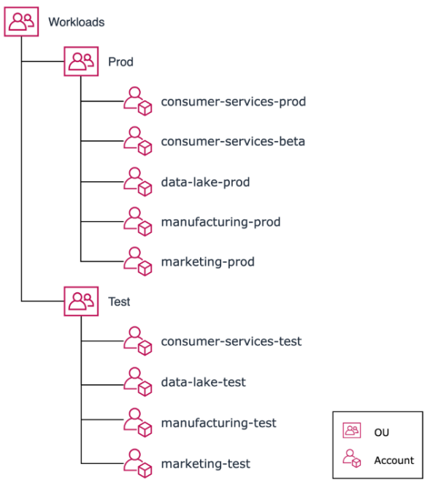

AWS Control Tower Account Factory
AWS Control Tower Account Factory is a console-based AWS Control Tower feature that you can use to provision new accounts in your organization. Account Factory functions as a UI for an AWS Service Catalog product and provisions custom accounts by using AWS CloudFormation. You can also conﬁgure Account Factory to optionally create VPCs and a NAT gateway in the new accounts. This configuration automatically provides a VPC with up to two subnets and a deﬁned Classless InterDomain Routing (CIDR) range in the AWS Regions that you specify.

AWS Control Tower add-ons
AWS Control Tower add-on solutions deliver enhanced features and customizations provided by AWS to augment the capabilities of AWS Control Tower. These enhancements are designed to seamlessly elevate the functionality of AWS Control Tower to help meet organizational requirements for increased eﬃciency, security, and compliance within the AWS environment. Examples include the following:
Landing Zone Accelerator (LZA) is an open-source solution from AWS that's designed to expedite the setup of a secure, multi-account AWS environment based on AWS best practices.
It streamlines the deployment of a landing zone and oﬀers automated processes for account creation, conﬁgurable security and compliance guardrails, and customizations to align with your organization's policies.

FAQ
This section provides answers to commonly raised questions about designing an AWS Control Tower landing zone.
Q. How can I use this guide in my design document?
A. You can replicate diﬀerent sections in this guide and use it as a template for your design document. You can also adapt the tables and diagrams in this guide to your speciﬁc requirements and conﬁgurations.
Q. Where can I ﬁnd more information about AWS Control Tower?
A. For sample features, FAQs, and pricing, see the AWS Control Tower web pages. For the user guide, best practices, and tutorials, see the AWS Control Tower documentation.
Q. How can I get started with AWS Control Tower?
A. Use the AWS Control Tower Workshop to set up your AWS Control Tower landing zone.
Q. Where can I ﬁnd architectures for AWS Control Tower?
A.Visit the AWS Architecture Blog, which has an AWS Control Tower category that provides diﬀerent architectural solutions and customizations.
Q. How can I further customize my AWS Control Tower landing zone?
A. You can use the Customizations for AWS Control Tower or Landing Zone Accelerator solution to customize your AWS Control Tower landing zone. To customize the accounts provisioned, you can use the Account Factory Customization (AFC) or the Account Factory for Terraform (AFT). For additional solutions that you can integrate with AWS Control Tower, see AWS Control Tower in AWS Marketplace.
Q. Where can I ﬁnd up-to-date information about all AWS Control Tower controls?
A. For complete information about current controls, see Controls reference guide in in the AWS Control Tower documentation.
Q. How can I automate operations in AWS Control Tower?
A. AWS Control Tower provides an API that exposes some of the most commonly used operations such as enabling or disabling controls, or provisioning or closing accounts. For more information, see Automate tasks in AWS Control Towerin AWS Control Tower in the AWS Control Tower documentation.
Q. Where can I ﬁnd more best practices for architecting multi-account environments on AWS?
A. See the white paper Organizing Your AWS Environment Using Multiple Accounts Using Multiple Accounts for additional guidance.
Q. Where can I ﬁnd more best practices for designing a secure landing zone?
A. See the AWS Security Reference Architecture for best practices for building a secure landing zone.


The content in this document is copyrighted; any unauthorized use – in part or full – may violate the copyright, trademark, and other laws. This document may not be modified, reproduced or publicly displayed, performed or distributed, or used for any public or commercial purposes. The Trianz name and its products are subject to trademark and copyright protections, regardless of how and where referenced.
Contact Information
Name
Email
Phone
reach@trianz.com
Thank You

